- Testing Techniques Used in the System

Below are some of the testing techniques that were used to detect errors and bugs in the Inventory System:
- Debugging each module – By running the Inventory System in Microsoft Visual Basic 6.0, it enables the programmer to easily detect bugs because a run-time error appears whenever the module can’t find any valid path or expressions needed by the module itself. The software automatically highlights in what part in each module does the run-time error exists. With this feature, the programmer can easily edit the runtime error.
- Tracing variable values in a selected path – In the Code Editor, the programmer can trace the values in a variable in the selected path set by the user. It is significantly useful in the Cashier Inventory System because there are complex computations done by its user through the use of an integer array. With this, the programmer can be assured that the computations are going well.
- Intentionally input unrealistic data – the user in either Employee’s Main Inventory System or Cashier’s Main Inventory System may intentionally input an unrealistic data like for example a portion of a record requires the user to input a date, but he/she intentionally inputs a string or a month/day that is not within its range and a run-time error will appear. However, there are validations that although the user type letters, but the portion of the record can only accept numbers so that portion will not display the letters typed by the user.

- List of “Error Messages”

- Select Login
- No selection
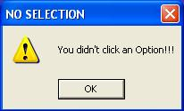
Figure 1
This error message (Figure 1) will appear if the user didn’t choose in any option button.

- Employee Login
- Access Denied
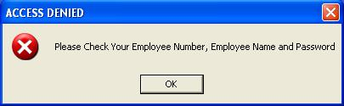
Figure 2
This error message (Figure 2) will appear if an unauthorized employee uses the system or if the employee incorrectly inputs an employee number, employee name, and / or password.

- Cashier Login
- Access Denied
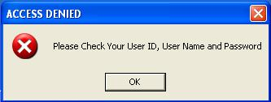
Figure 3
This error message (Figure 3) will appear if an unauthorized cashier uses the system or if the cashier incorrectly inputs a cashier ID, cashier name, and / or password.

- Employee Main Inventory
- Contacts
- Incomplete data
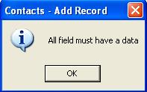
Figure 4
This error message (Figure 4) will appear if the employee inputs an incomplete supply of data in a record.

- No record to be modified
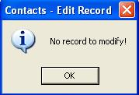
Figure 5
This error message (Figure 5) will appear if the employee clicks the EDIT Button but no record is shown in the Contact Listview to be edited.

- No record to be deleted
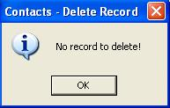
Figure 6
This error message (Figure 6) will appear if the employee clicks the DELETE Button but no record is shown in the Contact Listview to be deleted.

- Selecting a certain record
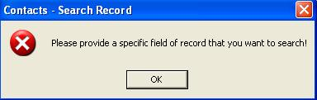
Figure 7
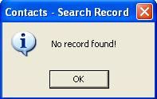
Figure 8
The error message (Figure 7) will appear if the employee clicks the SEARCH Button without specifying what the specific field of record to be searched. However, if the employee chooses in the a field in the Combo Box and type the record to be searched in the Text Box but the record didn’t exist in the Inventory System database, then an information prompt (Figure 8) will appear in the screen.

- Products
  - Incomplete data
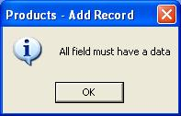
Figure 9
This error message (Figure 9) will appear if the employee inputs an incomplete supply of data in a record.

  - No record to be modified
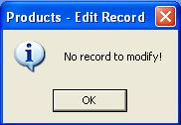
Figure 10
This error message (Figure 10) will appear if the employee clicks the EDIT Button but no record is shown in the Product Listview to be edited.

  - No record to be deleted
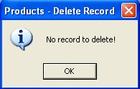
Figure 11
This error message (Figure 11) will appear if the employee clicks the DELETE Button but no record is shown in the Product Listview to be deleted.

  - Selecting a certain record
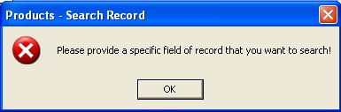
Figure 12
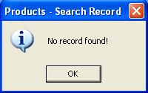
Figure 13
The error message (Figure 12) will appear if the employee clicks the SEARCH Button without specifying what the specific field of record to be searched. However, if the employee chooses in the a field in the Combo Box and type the record to be searched in the Text Box but the record didn’t exist in the Inventory System database, then an information prompt (Figure 13) will appear in the screen.

- Cashier Main Inventory
- Redundant Product ID

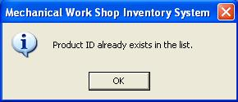
Figure 14
The error message (Figure 14) will appear if the cashier accidentally purchased 2 items with the same Product ID, which means that the second time the cashier purchased the product, he or she cannot purchased it.

- Inappropriate quantity

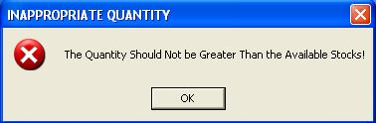
Figure 15
The error message (Figure 15) will appear if the cashier inputs a quantity in its corresponding Text Box that is greater than the stocks displayed in another Text Box.

- Invalid quantity

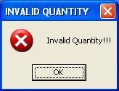
Figure 16
The error message (Figure 16) will appear if the cashier inputs 0 in the quantity Text Box.

- Insufficient stocks

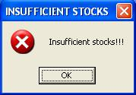
Figure 17
The error message (Figure 17) will appear if the user cannot purchase anymore a certain product because it is out of stock.

- Invalid cash amount

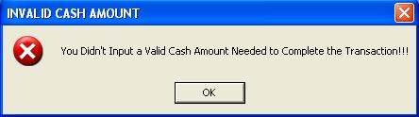
Figure 18
The error message (Figure 18) will appear if the cashier didn’t input a cash amount to be paid needed to finish the transaction because the user didn’t pay any amount.

- No Product to be returned

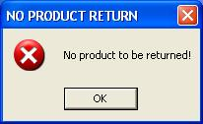
Figure 19
The error message (Figure 19) will appear if the cashier has no transactions conducted then no product to be returned.

- No total amount

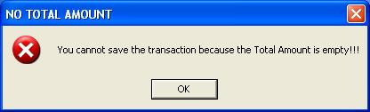
Figure 20
The error message (Figure 20) will appear if the cashier attempts to save the transaction without inputting the cash amount to be paid by the customer in its corresponding Text Box.

- Wrong Payment

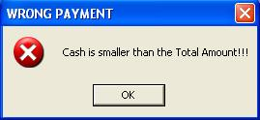
Figure 21
The error message (Figure 21) will appear if the user pays a cash amount that is less than the total amount needed to be paid.

- Change Employee Password
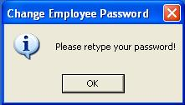
Figure 22
The error message (Figure 22) will appear if the employee’s new password didn’t match with its corresponding confirm password or if the employee number does not correspond with the old password.

- Change Cashier Password
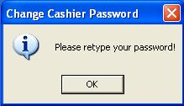

Figure 23
The error message (Figure 23) will appear if the cashier’s new password didn’t match with its corresponding confirm password or if the cashier id does not correspond with the old password.

- Sample “Test Cases” Used in the System

Test Case | Action | Result
1 | Click the Next Button without selecting any option button in the Selected Login Form. | Error message in Figure 1 appears.
2 | Select the Employee option and click the Next Button in the Selected Login Form. | Go to the Employee Login.
3 | Select the Cashier option and click the Next Button in the Selected Login Form. | Go to the Cashier Login.
4 | Input any Employee No., Employee Name, and/or Password that didn’t match the corresponding Employee Security database in the Employee Login. | Error message in Figure 2 appears.
5 | Input any Cashier ID, Cashier Name, and/or Password that didn’t match the corresponding Cashier Security database in the Cashier Login. | Error message in Figure 3 appears.
6 | Enter an Employee No., Old Password, New Password, and/or New Password that didn’t correspond in its Employee Security database in the Employee Login. | Error message in Figure 22 will appear.
7 | Enter a Cashier ID, Old Password, New Password, and/or New Password that didn’t correspond in its Cashier Security database in the Cashier Login. | Error message in Figure 23 will appear.
8 | Enter an Employee No., Old Password, New Password, and/or New Password that corresponds in its Employee Security database in the Employee Login. | New Password will be saved in the Employee Security database.
9 | Enter a Cashier ID, Old Password, New Password, and/or New Password that corresponds in its Cashier Security database in the Cashier Login. | New Password will be saved in the Cashier Security database.
10 | Input any Employee No., Employee Name, and/or Password that matches the corresponding Employee Security database in the Employee Login. | Go to the Employee Main Inventory System and the Employee Login database will add a new record.
11 | Input any Cashier ID, Cashier Name, and/or Password that matches the corresponding Cashier Security database in the Cashier Login. | Go to the Cashier Main Inventory System and the Cashier Login database will add a new record.
12 | Click the View All Button in the Employee Main Menu Inventory - Contacts | Go to the Contacts Listview.
13 | Click the View All Button in the Employee Main Menu Inventory - Products | Go to the Products Listview.
14 | Click the Add Button in the Employee Main Inventory System – Contacts. | Input all data needed in the contacts field.
15 | Click the Add Button in the Employee Main Inventory System – Products. | Input all data needed in the products field.
16 | Click the Edit Button without searching any record in the Employee Main Inventory System – Contacts. | Error message in Figure 5 will appear.
17 | Click the Edit Button without searching any record in the Employee Main Inventory System – Products. | Error message in Figure 10 will appear.
18 | Click the Edit Button with a record in the Employee Main Inventory System – Contacts. | Selected record will be updated in the Contacts database.
19 | Click the Edit Button with a record in the Employee Main Inventory System – Products. | Selected record will be updated in the Products database.
20 | Input contact fields incompletely when the Save Button is active in the Employee Main Inventory System – Contacts. | Error message in Figure 4 will appear.
21 | Input product fields incompletely when the Save Button is active in the Employee Main Inventory System – Products. | Error message in Figure 9 will appear.
22 | Input contact fields completely when the Save Button is active in the Employee Main Inventory System – Contacts. | New contact record will be saved in the Contacts database.
23 | Input product fields completely when the Save Button is active in the Employee Main Inventory System – Products. | New product record will be saved in the Products database.
24 | Click the Delete Button without a record appeared in the Employee Main Inventory System – Contacts. | Error message in Figure 6 will appear.
25 | Click the Delete Button without a record appeared in the Employee Main Inventory System – Products. | Error message in Figure 11 will appear.
26 | Click the Delete Button with a record appeared in the Employee Main Inventory System – Contacts. | Selected record will be deleted in the Contacts database.
27 | Click the Delete Button with a record appeared in the Employee Main Inventory System – Products. | Selected record will be deleted in the Products database.
28 | Click the Search Button without specifying either the field/record to be searched in the Employee Main Inventory System – Contacts. | Error message in Figure 7 will appear.
29 | Click the Search Button without specifying either the field/record to be searched in the Employee Main Inventory System – Products. | Error message in Figure 12 will appear.
30 | Click the Search Button with the field/record to be searched that didn’t match with the data in the Contacts database in the Employee Main Inventory System – Contacts. | Error message in Figure 8 will appear.
31 | Click the Search Button without the field/record to be searched that didn’t match with the data in the Products database in the Employee Main Inventory System – Products. | Error message in Figure 13 will appear.
32 | Click the Search Button with the field/record to be searched that matches with the data in the Contacts database in the Employee Main Inventory System – Contacts. | Searched record will appear in the Employee Main Inventory System - Contacts.
33 | Click the Search Button without the field/record to be searched that matches with the data in the Products database in the Employee Main Inventory System – Products. | Searched record will appear in the Employee Main Inventory System - Products.
34 | Click the New Search Button in the Employee Main Inventory System – Contacts. | Clears all records that appear in the Employee Main Inventory System – Contacts.
35 | Click the New Search Button in the Employee Main Inventory System – Products. | Clears all records that appear in the Employee Main Inventory System – Products.
36 | Click the Cancel Button in the Employee Main Inventory System –Contacts. | Cancels the add, edit or delete operations in the Employee Main Inventory System – Contacts
37 | Click the Cancel Button in the Employee Main Inventory System – Products. | Cancels the add, edit or delete operations in the Employee Main Inventory System – Products.
38 | Click the Contacts Button in the Employee Main Inventory System – Reports. | Go to the Contacts report.
39 | Click the Products Button in the Employee Main Inventory System – Reports. | Go to the Products report.
40 | Click the Employee Login Button in the Employee Main Inventory System – Reports. | Go to the Employee Login report.
41 | Click the Cashiers Login Button in the Employee Main Inventory System – Reports. | Go to the Cashiers Login report.
42 | Click the Sales Button in the Employee Main Inventory System – Reports. | Go to the Sales report.
43 | Click the Transactions Button in the Employee Main Inventory System – Reports. | Go to the Transactions report.
44 | Input a Product ID in the Product ID Textbox that matches with the corresponding Product ID in the Products database in the Cashier Main Inventory System. | Displays the product record in the Cashier Main Inventory System.
45 | Add the same Product ID twice in the Cashier Main Inventory System. | Error message in Figure 14 appears.
46 | Input a quantity that is greater than the number of available stocks in the Cashier Main Inventory System. | Error message in Figure 15 appears.
47 | Input 0 in the Quantity textbox in the Cashier Main Inventory System. | Error message in Figure 16 appears.
48 | Input any quantity wherein there is no available stock in the Cashier Main Inventory System. | Error message in Figure 17 appears.
49 | Click the Save Button without inputting a Cash On Hand in its corresponding textbox in the Cashier Main Inventory System. | Error message in Figure 18 appears.
50 | Click the View Product Button in the Cashier Main Inventory System. | Go to the Products Listview.
51 | Add a product to be purchased. | Selected product will appear in the Cashier Main Inventory System and the Sales database will add a new record.
52 | Return a selected product that appears in the Cashier Main Inventory System. | Product will be returned and the stocks will remain the same as if there is no transaction done.
53 | Return a selected product that does not appear in the Cashier Main Inventory System. | Error message in Figure 19 will appear.
54 | Save the transaction without purchasing anything in the Cashier Main Inventory System. | Error message in Figure 20 will appear.
55 | Save the transaction with a purchased product in the Cashier Main Inventory System. | Transaction will be saved and the Transactions database will add a new record.
56 | Click the Log Out / Exit Button in any of the forms. | Exits the Inventory System and either the Employee Login or the Cashier Login will be updated.

